11. Write a PHP program for student registration.

<! Doctype html>

<html lang="en">

<head>

  <meta charset="utf-8">

  <meta name="viewport" content="width=device-width, initial-scale=1, shrink-to-fit=no">

  <title> PHP Registration Form </title>

<style>

input[type=radio] { width:20px; }

input[type=checkbox]{ width:20px; }

* {   padding: 0;   margin: 0;  box-sizing: border-box; }

body {   margin: 50px auto;  text-align: center;   width: 800px;  }

input[type=reset] {

  border: 3px solid;

  border-radius: 2px;

  color: ;

  display: block;

  font-size: 1em;

  font-weight: bold;

  margin: 1em auto;

  padding: 1em 4em;

 position: relative;

  text-transform: uppercase;

}

input[type=reset]::before

{    background: #fff;  content: ''; position: absolute;   z-index: -1;    }

input[type=reset]]:hover {    color: #1A33FF;   }

input {   border: 2px solid #ccc;   font-size: 1rem; font-weight: 100;  font-family: 'Lato';   padding: 10px; }

form {   margin: 20px auto;  padding: 20px;  border: 5px solid #ccc; background: #8bb2eafa;  }  h1 {

    font-family: sans-serif;   display: block;  font-size: 2rem;  font-weight: bold;

  text-align: center;  letter-spacing: 3px;   color: hotpink;   text-transform: uppercase;  }

    input[type=submit] {

  border: 3px solid;    border-radius: 2px;     color: ;     display: block;

  font-size: 1em;     font-weight: bold;     margin: 1em auto;    padding: 1em 4em;

 position: relative;     text-transform: uppercase;   }

input[type=submit]::before

{     background: #fff;     content: '';    position: absolute;     z-index: -1;    }

input[type=submit]:hover {

  color: #1A33FF;

}

</style>

</head>

<body>

<h1> PHP Registration Form </h1>

<form method="post" enctype="multipart/form-data" action =?#?>

<table>

 <tr>

    <td colspan="2"> <?php echo @$msg; ?> </td>

 </tr>

  <tr>

    <td width="159"> <b> Enter your Name </b> </td>

    <td width="218">

    <input type="text" placeholder="Enter name" name = "n"  pattern="[a-z A-Z]*" required /> </td>

  </tr>

  <tr>

    <td> <b> Enter your Email </b> </td>

    <td> <input type="email" name="e"/ placeholder= "Enter Email" > </td>

  </tr>

  <tr>

    <td> <b> Enter your Password </b> </td>

    <td> <input type="password" name="p"/ placeholder=" Enter Password" > </td>

  </tr>

  <tr>

    <td> <b> Enter your Address </b> </td>

    <td> <textarea name="add">  Enter Address </textarea> </td>

  </tr>

  <tr>

    <td> <b> Enter your Mobile Number </b> </td>

    <td> <input type="text" pattern="[0-9]*" name="m" / placeholder=" Enter number" > </td>

  </tr>

  <tr>

    <td height="23"> <b> Select your Gender </b> </td>

    <td>

    Male <input type="radio" name="g" value="m"/>

    Female <input type="radio" name="g" value="f"/>

    </td>

  </tr>

  <tr>

    <td> <b> Choose your Hobbies </b> </td>

    <td>

        Cricket <input type="checkbox" value="cricket" name="hobb[]"/>

        Singing <input type="checkbox" value="singing" name="hobb[]"/>

        Dancing <input type="checkbox" value="dancing" name="hobb[]"/>

    </td>

  </tr>

  <tr>

    <td> <b> Select your Profile Pic </b> </td>

    <td> <input type="file" name="pic"/> </td>

  </tr>

  <tr>

    <td> <b> Select your Date of Birth </b> </td>

    <td>

        <select name="mm">

            <option value=""> Month </option>

            <?php

            for($i=1;$i<=12;$i++)

            {

            echo "<option value ='$i'>".$i."</option>";

            }

            ?>

        </select>

        <select name="dd">

            <option value=""> Date </option>

            <?php

            for($i=1;$i<=31;$i++)

            {

            echo "<option value ='$i'>".$i."</option>";

            }

            ?>

        </select>

        <select name="yy">

            <option value=""> Year </option>

            <?php

            for($i=1900;$i<=2015;$i++)

            {

            echo "<option value ='$i'>".$i."</option>";

            }

            ?>

        </select>

    </td>

  </tr>

  <tr>

    <td colspan="2" align="center">

    <input type ="submit" name="save" value="Register"/>

    <input type="reset" value="Reset"/>

    </td>

  </tr>

</table>

</form>

</body>

</html>

<?php

extract($_POST);

if(isset($save))

{

$dob=$yy."-".$mm."--".$dd;

$h=implode(",",$hobb);

$img=$_FILES['pic']['name'];

if($return)

{

$msg="<font color='red'>".ucfirst($e)." already exists choose another email </font>";

}

else

{

$msg= "<font color='blue'> your data saved </font>";

}

}

?>

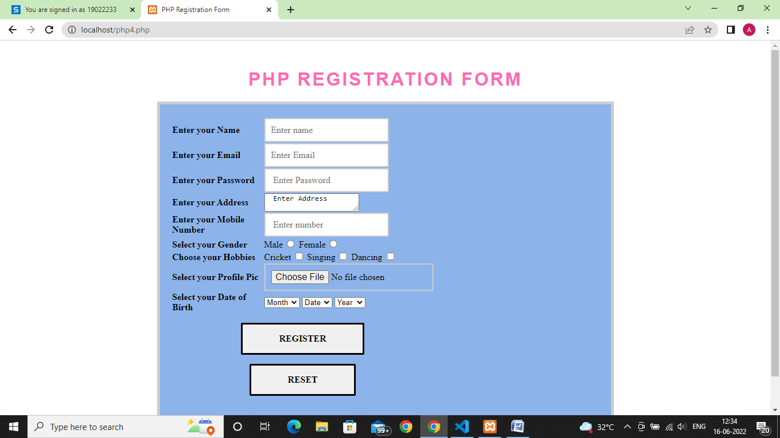

12. Write a PHP program to open a txt file in ‘w’ mode and inserting the text into a file and then read the text from file.

<?php

$myfile = fopen("newfile.txt", "w") or die("Unable to open file!");

$txt = "Javagram\n";

fwrite($myfile, $txt);

$txt = "Web Program\n";

fwrite($myfile, $txt);

$txt = "Ds Program\n";

fwrite($myfile, $txt);

fclose($myfile);

$myfile = fopen("newfile.txt", "r") or die("Unable to open file!");

while(!feof($myfile))

{

  echo fgets($myfile) . "<br>";

}

fclose($myfile);

?>

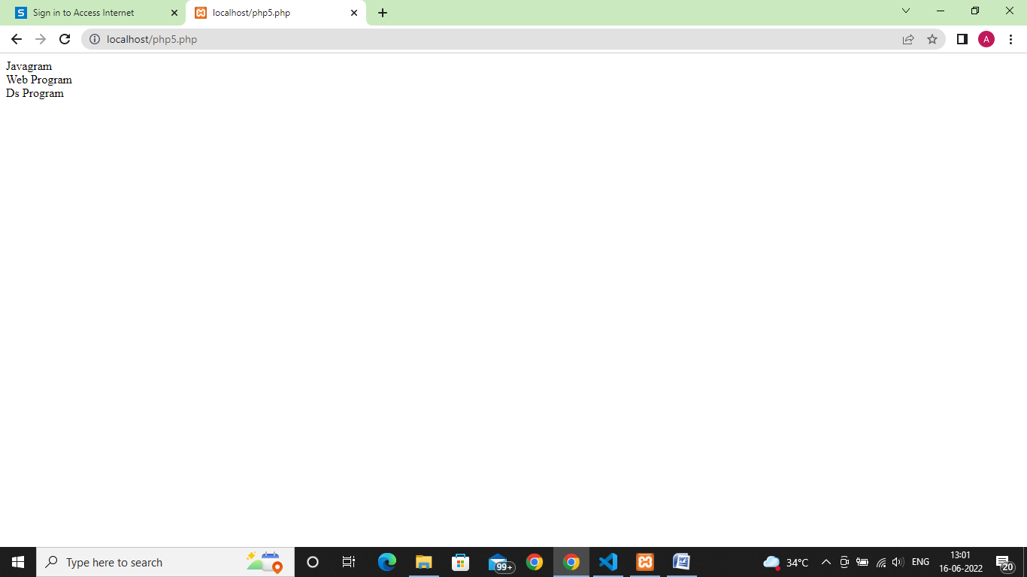

13. Write a PHP program to implement include and require.

<?php

include '_connectdatabase1.php';

echo "hello";

require  '_connectdatabase1.php';

?>

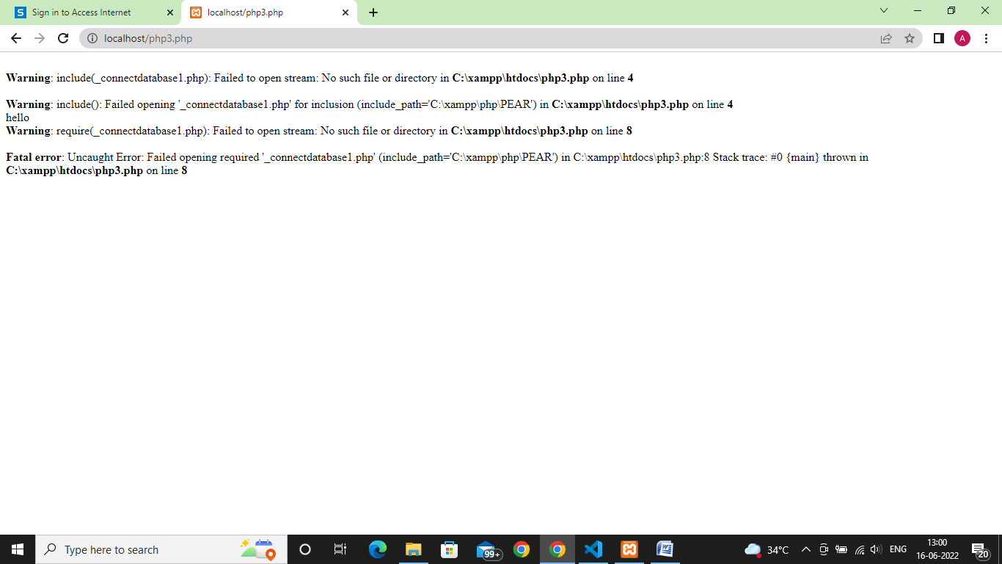

14. Write a PHP program to connect a database and check the connection is successful or not.

<?php

//echo "welcome to mysql database<br>";

// connect to the database

$servername="localhost";

$username="root";

$password="";

// create a connection

$conn=mysqli_connect($servername,$username,$password);

$sql="CREATE DATABASE anjali";

$result = mysqli_query($conn,$sql);

if($result)

{

    echo "db was created successfully";

}

else{

    echo "db was not  created successfully because of error".mysqli_error($conn);

}

if(!$conn)

{

    die("sorry we failed to connect: ". mysqli_connect_error());

}

else

{

echo "connection was successful";

}

?>

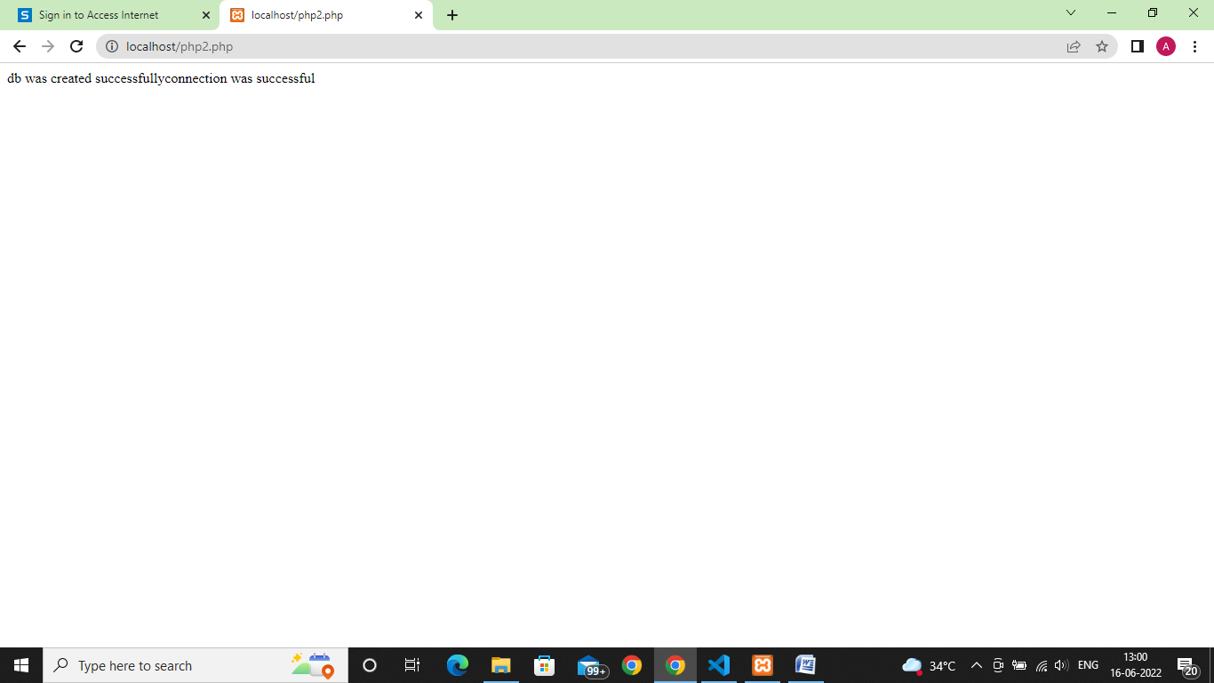

15. Write a PHP program to create , insert , update , delete data in database using SQL queries.

<?php

//echo "welcome to mysql database<br>";

// connect to the database

$servername="localhost";

$username="root";

$password="";

$database="urvashi";

// create a connection

$conn=mysqli_connect($servername,$username,$password,$database);

 $sql="CREATE TABLE ab (SNO INT NOT NULL AUTO_INCREMENT , NAME VARCHAR(22) NOT NULL , DEST VARCHAR(12) NOT NULL , PRIMARY KEY (SNO))";

 $result = mysqli_query($conn,$sql);

 if($result)

 {

     echo "table  was created successfully";

 }

 else{

     echo "Table was not  created successfully because of error".mysqli_error($conn);

 }

$i_v="INSERT INTO ab2 (NAME, DEST) VALUES ('URVASHI', 'geu')";

$sql = "INSERT INTO ab2 (sno,name, dest) VALUES ('1','urvashi', 'geu')";

$result = mysqli_query($conn, $i_v);

//Add  new trip to the Trip table in the database

 if($result){

     echo "The record has been inserted successfully successfully!<br>";

 }

 else{

     echo "The record was not inserted successfully because of this error ---> ". mysqli_error($conn);

 }

$sql = "SELECT * FROM ab";

$result = mysqli_query($conn, $sql);

$num = mysqli_num_rows($result);

echo $num;

echo " records found in the DataBase<br>";

$sql = "SELECT * FROM ab WHERE dest='geu'";

$result = mysqli_query($conn, $sql);

// Usage of WHERE Clause to fetch data from the database

$num = mysqli_num_rows($result);

echo $num . " records found in the DataBase<br>";

$no=1;

if($num> 0){

    while($row = mysqli_fetch_assoc($result)){

        echo $no .  ". Hello ".$row['NAME']." address ".$row['DEST'];

        //echo $row['NAME'];

        echo "<br>";

        $no = $no +1;

    }

}

if(!$conn)

{

    die("sorry we failed to connect: ". mysqli_connect_error());

}

else

{

echo "connection was successful";

}

?>

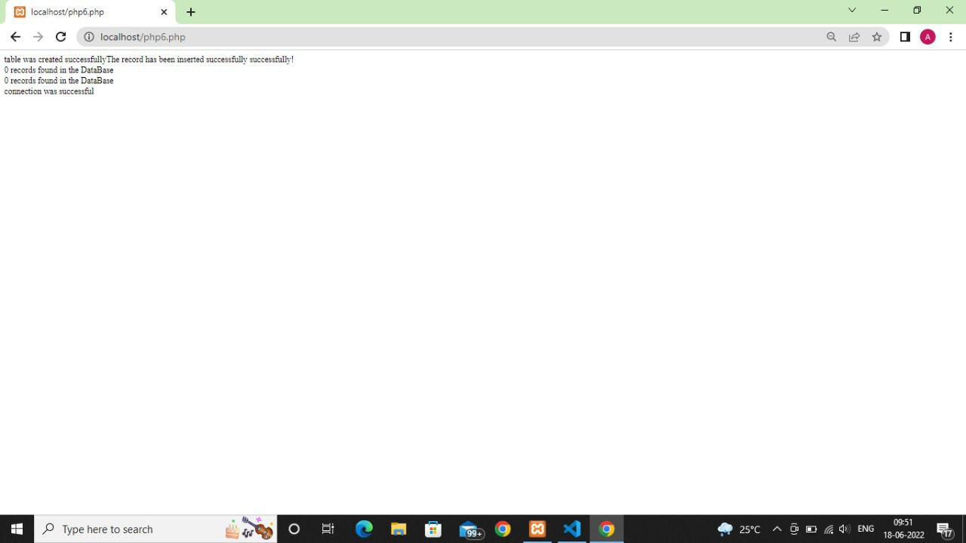

16. Write a JQUERY program to display JSON data.

<!DOCTYPE html>

<html lang="en">

<head>

    <meta charset="UTF-8">

    <meta http-equiv="X-UA-Compatible" content="IE=edge">

    <meta name="viewport" content="width=device-width, initial-scale=1.0">

    <title>Read json data </title>

</head>

<body>

<h1>read json data</h1>

   <div id ="load-data"></div>

<script src="jquery-3.6.0.min.js"></script>

<script>

    $(document).ready(function () {

        $.ajax({

            url:"https://jsonplaceholder.typicode.com/posts/1",

            type:"GET",

            success: function(data){

                $("#load-data").append(data.id +"<br>" +data.title+"<br>"+data.body);

            }

        });

    });

</script>

<!-- <script src="https://code.jquery.com/jquery-3.6.0.slim.min.js" integrity="sha256-u7e5khyithlIdTpu22PHhENmPcRdFiHRjhAuHcs05RI=" crossorigin="anonymous"></script> -->

</body>

</html>

